Safe Start Q&A 21 Oct 2013

Vladimir,

The following points are some more queries I have regarding the Safe Start system:

1. **Connection error should not show when using the app**
   * When using the app, we were getting some connection errors when trying to move past the first screen. The app should be able to be used completely offline (no internet connection) for both email and database system. Is this not the case?
   * We will investigate the problem, yes, the app should be able to be used offline, in case, if a user has opened (and logged in) it at least once.
2. **Wrong parameters error when trying to submit?**
   * When creating an inspection on the phone app, with additional checklists, we are getting a “Wrong parameters” error. Is this a bug being fixed?
   * It should be fixed already, do you have it again now?
   * Yes we are still experiencing it with the latest build you have sent for iOS.
3. **180 hours full rewrite for Desktop Application.**
   * As mentioned to Kate, we would like to proceed with a full rewrite for the Desktop Application (using Ext JS?). I will await further feedback from your team regarding this.
   * OK
4. **8 hours for lost password**
   * We would like to proceed with this change request. Please advise what information you require.
   * We need the description of how it should work. As I remember, a user gets email with a link, he clicks on it and goes to a screen where he can change his password.
   * Basic process flow is:
     1. User clicks “Forgot Your Password?” link on login page
     2. They are prompted to enter their email and press Request Password Reset button.
     3. Once submitted the webpage will say “A password reset request has been sent to your email. Please check your inbox now.”
     4. Email is then sent to user with time-sensitive link (24 hours) to change their password.
     5. User clicks link and is directed to page where they can enter a new password, with a second text box to confirm.
     6. Once password is changed a confirmation message shows “You have successfully changed your password!”
   * Side note: Database users (operators) should not be able to change password. Credentials must be sent manually to these users by admin or responsible persons.
5. **Next service due/current odometer.**
   * If a user enters a value for Next Service Due in either the Kms or Hours field, they will be required to enter a value into Current Odometer for either Kms or Hours (depending on which field they had entered in Next Service Due). So, these are the possible cases:
     1. Data entered in Kms (Next Service Due) 🡪 User MUST enter data in Kms (Current Odometer) and is NOT required to enter data for Hours (both Next Service Due and Current Odometer). My point is that both pairs of data are NOT required fields – just one (kms or hours). BOTH pairs can be filled however.
     2. OK
6. **Operators name database settings**
   * Please add the field Operator’s name to the Database settings in the app. We have decided that multiple database users will use one account (created by the database admin) but will be differentiated by their Name. This can be input via the settings screen and auto-filled into the first page of the inspection.
   * Isn’t it more comfortable for users to have one account per one user? It’s quiet easy to create as many users, as a company needs.
   * We want to make the process as easy as possible to allow companies to adapt this into their regular workflow. Some companies may have hundreds of employees out in the field, so creating user accounts for each operator may be a time-consuming factor that may prevent users from fully utilizing the system. By having one account, or a few group accounts that multiple operators use, this makes it easier for admins. However these low-level users (operators) should not be able to change the password using the password reset functionality above.
7. **Remove operators email address from email settings**
   * Please remove this field.
8. **Auto-capitalisation**
   * Can we have auto-capitalisation of words in the iOS apps?
   * I will discuss it with iOS developer later.
9. **GPS map output**
   * Is this still being implemented in the Output PDF and database report? Using the device location coordinates it should create a small Google Map to show location of vehicle.
   * Now you can see a map if a user has enabled GPS option in the “Previous inspection” -> “Location” field.
   * Will the map also be in the Output PDF?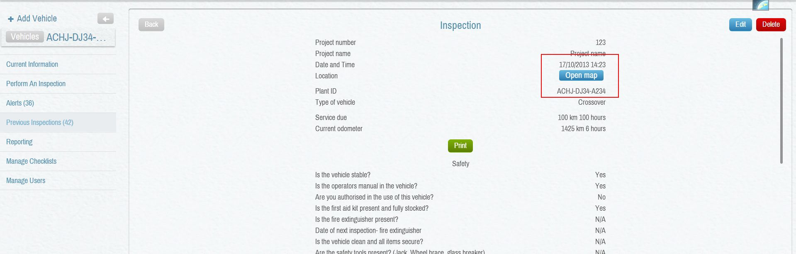
10. **Plant IDs are not case-sensitive**
    * Just a point for your developers in case this can cause errors in the system.
    * OK
11. **Red pop ups need to removed from non-errors**
    * When clicking a negative value (Trigger Filled Value) a red alert pops up everytime. This is not necessary as a default function. It should only pop up if the admin has specified it to do so.
    * That’s because we have all fields were critical, I’ve fixed it already.
12. **App needs to be used offline**
    * As mentioned above, the app needs to be able to be used offline, with pending inspections waiting in an outbox for internet connectivity to return to the device.
    * OK
13. **Registration expiry field to be added to 1st screen of inspection**
    * As per FR_006, the registration expiry date needs to be in the 1st screen of the inspection.
    * OK
14. **iOS keyboard functionality**
    * Is it possible to have Previous, Next and Hide Keyboard buttons present on the iOS Keyboard? Previous and Next should jump between previous and next fields on the current checklist respectively.
    * I don’t think it’s possible. As I’ve know, we can’t change iOS keyboard. I’ll ask iOS developer tomorrow.
    * OK please check – it will make navigation much easier for users.
15. **Predictive text for plant IDs in database system**
    * When using the database system in the app and beginning to type the Plant ID in the first screen of the inspection, will a list of Plant IDs drop down, or can we have some predictive text show the appropriate Plant IDs for the user to select from?
    * OK, I think we can do this.